Data mobilization call 2025

2025 call for project proposals for co-funding the preparation of your species occurrence data and ensuring the data quality before datasets are published in GBIF and the Norwegian Species Map (Artskart).

Application deadline 15th June 2025

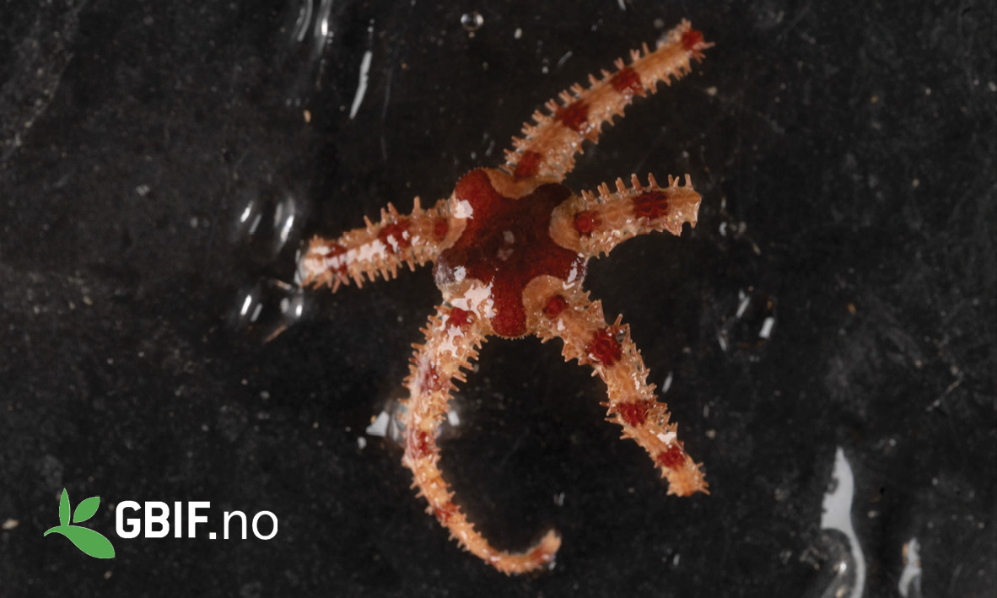
Crevice brittle star Ophiopholis aculeata
(Linneaus, 1767). © Andreas Altenburger

Co-funding to prepare and publish species occurrence data (2025)
Call for data mobilization proposals for the preparation of your species occurrence data and ensuring the data quality before datasets are published in GBIF and the Norwegian Species Map (Artskart). Successful applications receive co-funding contributions as a grant to the applicant institution. The responsible institution is expected to provide complementary self-funded work or financial contributions matching the financial support from GBIF Norway. The total budget for this call is 500 000 NOK (approximately 42 000 Euro) and the maximum contribution from GBIF Norway to each project is 100 000 NOK (approximately 8 400 Euro).

Priority criteria:
- Marine species (explore the OBIS data stream)
- Environment DNA data (or other DNA sequence data) -- explore the Metabarcoding toolkit
- Ecological sampling event data -- using the Humboldt Extension - and the new DwC Data Package format
- New data publishers based in Norway (Datasets from Norwegian institutions not yet publishing datasets in GBIF)
- Proposals are also evaluated based on the level of co-funding
Project requirements:

- This call addresses Norwegian institutions.
- Datasets prepared for publication must follow the international Darwin Core data standard. Characteristics of eligible datasets include for each data record, a mandatory taxon name, geographic location (preferably georeferenced), and temporal description (date or time period). Species occurrence data should contain presence/absence information or quantitative information.
- Scientific taxon names must be validated against the Norwegian National checklist (Artsnavnebasen) or against other relevant regional or global checklists such as the Catalogue of Life or Global Names.
- We recommend that datasets are validated using the GBIF data validator tool.
- All resulting datasets must be openly published to GBIF and Artskart (using GBIF IPT, Artsobservasjoner, or similar). Datasets can be prepared following the format of the Darwin Core spreadsheet template provided from GBIF (or the template from GBIF Norway) and sent by email to GBIF Norway (helpdesk@gbif.no). The responsible institute can alternatively install and use standard data publishing software such as the GBIF Integrated data Publishing Toolkit (IPT).
- Sensitive species occurrence data must be managed in the appliance with the guidelines and regulations provided by the Norwegian Environment Agency (Miljødirektoratet) and the Ministry of Climate and Environment (Miljødepartementet). See also the guidelines and regulations for open access to public data (Offentlighetsloven) provided by the Norwegian Agency for Public Management and eGovernment (DIFI.no) and the Government of Norway.
- Resulting species occurrence datasets must be licensed either as Creative Commons Zero (CC0) or as Creative Commons Attribution (CC-BY-4.0) to be compatible with the GBIF data sharing agreement. And the FAIR data principles (Wilkinson 2016).
- If the application includes the preparation of species occurrence data from another data owner than the project coordinating institution, the respective public access to these data must be agreed and consolidated with the data owner in advance.
- Co-funding from this call will only be provided for the preparation and subsequent publication of species occurrence data. Funding for fieldwork to collect information or biological material is not eligible for funding under this call. Funding for research activities or activities to manage or physically conserve the respective biological material is not eligible for funding under this call.
- GBIF Norway strongly recommends that data owners prepare metadata descriptions on dataset level following the Ecological Metadata Language (EML) and that all specimens and data records are assigned persistent and globally unique identifiers (such as UUID or DOI).
- All applicants must provide a basic data management plan (DMP) describing how the mobilized dataset will be managed in compliance with best practices and the data requirements of this call.
If successfully co-funded projects are significantly delayed, or the pre-requisites (technical, scientific, economical, or with respect to progress) are no longer present, then GBIF Norway must be notified.
Proposals are evaluated based on the criteria here in the call and in the application form. The cost per data record and the data management plan will also be considered for the evaluation.

Application form for project co-funding (contribution grant) for preparation and ensuring data quality of Norwegian species occurrence data to be published in GBIF and the Norwegian Species Map (Artskart) (2025).

Contact information
Name
Institution
Address
E-mail
Phone number

Application details
Taxon group(s)
Description of respective limitations in the dataset(s) with respect to species composition or geographical or temporal coverage.
Describe to what degree the respective datasets are already available in an electronic format.
Short description of the planned work (max 200 words).
Data owner (institution)
Project leader
Other participants
Estimate the total number of species occurrence records
Data license (CC0, CC-BY)
Project period, including end date.
Name of the responsible person within your institution (who will sign the grant contract).
Description and estimate of the level of own co-funded contribution (max 100 words).
Application amount (max 100 000 NOK per project).

Prioritized criteria | Assessment by applicant: 0 = no, 1 = low degree, 2 = some, 3 = high degree; or describe
Does the dataset(s) include marine species?
Does the dataset(s) include environment DNA data (or other DNA sequence data)?
Does the dataset(s) include ecological sampling event data -- using the Humboldt Extension - and the new DwC Data Package format?
Is the institution a new data publisher based in Norway?

The application and eventual appendices should be sent by e-mail to GBIF Norway: helpdesk@gbif.no

The deadline for applications this year is June 15th, 2025.

For questions regarding the application, contact Vidar Bakken, <vidar.bakken@usit.uio.no>, Dag Endresen, <dag.endresen@nhm.uio.no> or GBIF Norway helpdesk at <helpdesk@gbif.no>.

URL: https://www.gbif.no/projects/call/data-publication-call-2025.html

